Computer Organisation 1 Week 10 Tutorial Questions

- Show that the following logical operations are equivalent using both truth tables and Venn diagrams:
~(P v Q) ⇔ ~ Pˆ ~ Q
A+A’.B = A + B (Can use = instead of ⇔)
A + 1 = 1
A.1 = A
(a + b)(a + c) = a + bc

2. Show, by means of a truth table, that x.y’. (x + y + z) = x.y’

3. Show by means of a truth table or otherwise that

P. (Q’ + R’) = ~(P’ + Q.R)

(a + b) . (b’ + a) = a
4. Simplify the following logic expressions
A.B’ + A’.B’ a.b + a’.b + a’.b’ (x + x’.y) + t.(t’+ w)

5. Design a logic network for each of the following so that the output is described by the Boolean expression

  - (a + b)(a’ + c)
  - a’b + bc + a
  - ac + a’ + bc’
  - abc + a’b’c’

6. Show how to represent OR using NAND logic gates
(Hint : Use De M’ to get NANDs : x+y = ~(x’y’) )

7. Give a Boolean expression describing the output of each of these logic networks:

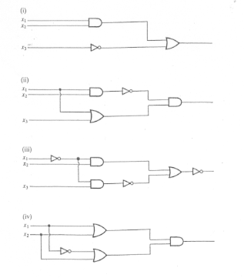

8. Find the NOR gate form for the Half-adder (Hint : Use De M’ on ab’ + a’b to get combinations of a+b, a’+b’ etc)

